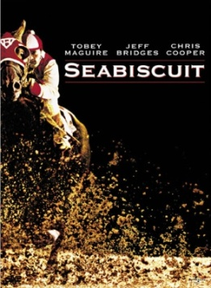
American history
Movie review worksheet
30 Points

Seabiscuit (2003)

Directed by: Gary Ross Run Time: 141 min.
Plot: In an era when Americans were in great need of heroic figures to help them forget their troubles, SEABISCUIT comes to the rescue. The picture relates a moving story of friendship and devotion in rehabilitating the main characters’ fractured lives, as it interweaves the interactions between horse, jockey, trainer and owner and their adoring fans. The film accurately portrays the real people and events of those troubled times and how Seabiscuit "fixed us, every one of us."
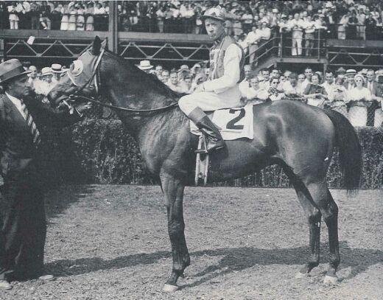
Cast:
Tobey Maguire – Red Pollard
Jeff Bridges – Charles Howard
Chris Cooper – Tom Smith
Elizabeth Banks – Marcela Howard
William H. Macy – Tick Tock McGlaughlin
Gary Stevens – George Woolf
David McCullough – Narrator

Useless Trivia:
• Over 40 horses are featured in the film, with 10 sharing the role of Seabiscuit.
• Most of the audience at the Pimlico Race with War Admiral were blow-up mannequins
with masks as faces, long sleeve T-Shirts with painted on suits, and plastic hats.
• While the movie describes War Admiral as being a huge horse close to eighteen hands
tall, the real-life War Admiral was well known for being one of the smallest sons of Man
o' War. War Admiral was actually the same size as Seabiscuit, which was
approximately fifteen hands tall.
• In the scenes filmed at Santa Anita racetrack you can see a statue of a horse by the
paddock. This statue is a memorial to Seabiscuit that exists at Santa Anita. Another
statue stands approximately 100 yards away; this is a tribute to George Woolf.
• In the montage of still photographs purporting to show the first year of the Great
Depression, a truck is visible with a 1937 license plate.
• Anachronisms: Before Seabiscuit and Red's first race, when Seabiscuit is being
loaded into the starting gate, you can see the Santa Anita racetrack sign in the
background, with a digital scoreboard. Digital scoreboards were first manufactured in
the 1980's.
• Continuity: When Red is racing with George, George says, "There's my hole; gotta
go." In the replay, he says, "There's my hole; gotta fly."
• Anachronisms: The jockeys all wear clear plastic safety lenses, which weren't used
until after World War II.

QUESTIONAIRE (20 pts)

- How much time did it take to produce a Model T utilizing the assembly line?

- How does Charles get his first shot as a businessman?

- What writer’s poem does Johnny(Red) have to recite from memory to get his first horse?

- How much money does Johnny make for the family taking care of horses?

- Where is Frankie going when he has the car accident?

- Where does Charles meet Marcela(his 2nd wife)?

- Who was Seabiscuit’s father(sire)?

- Why does Red end up blind in one eye?

- What does Smith do to finally calm Seabiscuit down?

- What was the rumor about the Seabiscuit’s pre-race routine?

- Seabiscuit was best in the west, but who was the “best in the
east”?

- How much was the purse offered to try and get the best horses to California?

- Why didn’t War Admiral’s owner want to race Seabiscuit?

- What is Red doing when he breaks his leg?
- Who rides in Red’s place against War Admiral?

- What happens to Seabiscuit in his first race back at home?

- When do Mr. and Mrs. Howard notice Red is thinking about racing again?

- Why does Red feel so betrayed when Seabiscuit gets to race in the $100,000 race?

- How does Seabiscuit “get back in the race” at Santa Anita?

- What number was Seabiscuit wearing?

ESSAY (15 pts)

Red closes the movie saying, “Everyone thinks we found this broken down horse and fixed him, but we didn’t. He fixed us.” How does this quote apply literally to the characters and metaphorically to the United States? Use at least 3 examples from the movie to explain your answer.

